

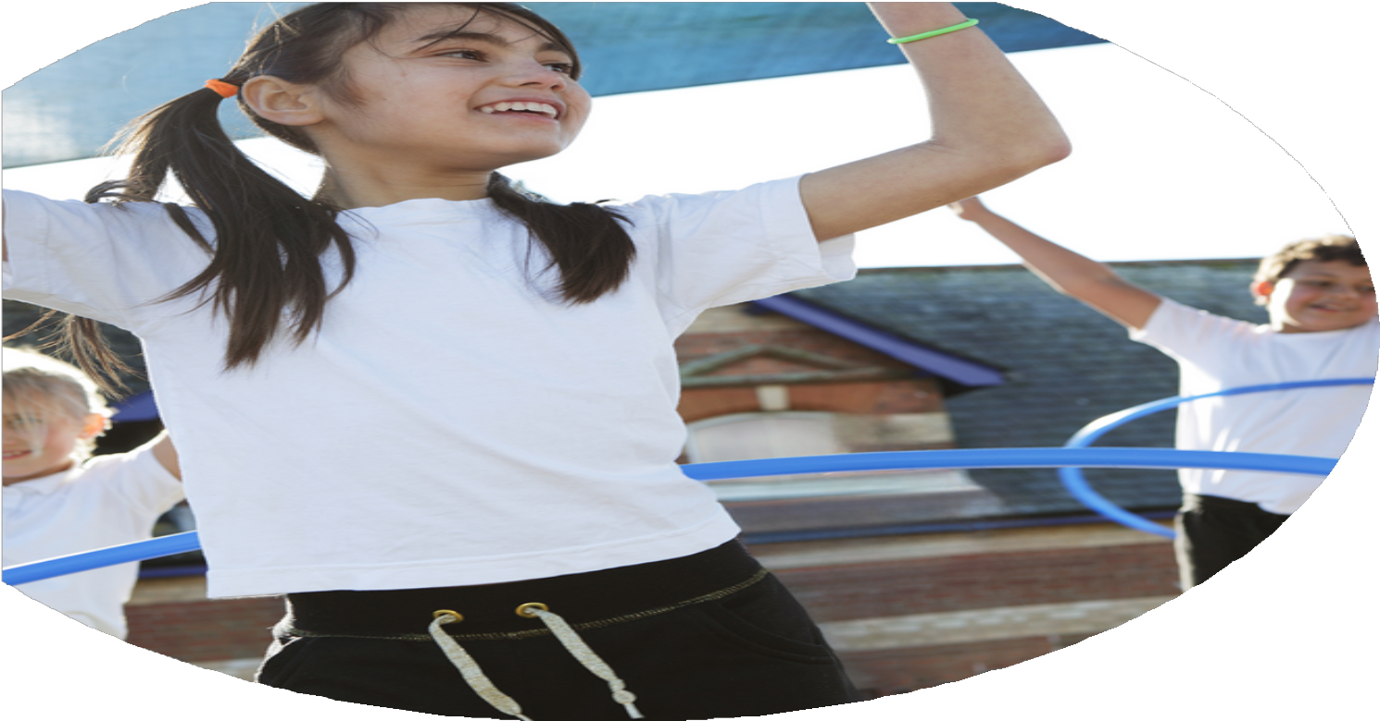
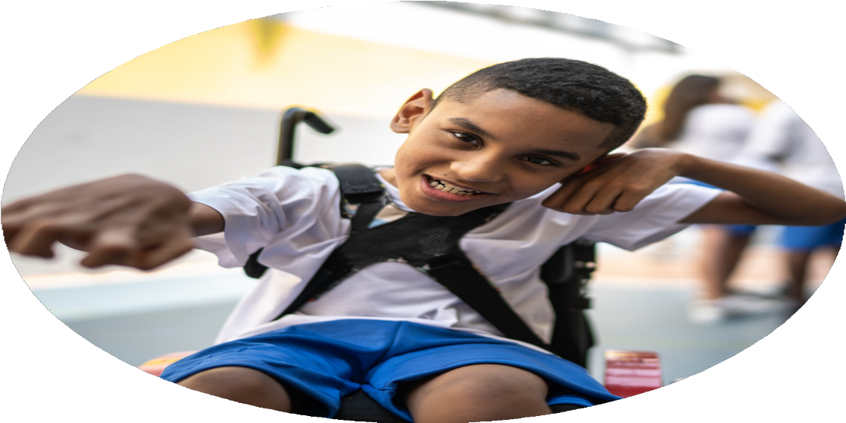




PE Funding

Evaluation Form

2024-25

Commissioned by

Created by

Action – what we did | Who does this action impact? | Impacts
- Purchase of new scooters and helmets to go with them | All children | - Scooters developed children’s enthusiasm and encouraged more family’s to walk or scoot to school.
- Purchase of new balls, batts and other playground equipment | All children | - Children increased the amount of physical activity during the day through excellent playground resources
- Employ additional lunchtime supervisors to support enhanced playtime activity and playground games | All children | - Higher participation and engagement in physical activities throughout playtime and lunchtime
- Purchase of new family friendly physical development equipment, such as throwing and catching, balls, bats and skipping ropes. Make it sustainable with high quality storage facilities | All children and parents | - Children had access to resources before school to promote whole family physical development  - Higher attendance as children and parents want to come to school to engage in activities before school
- Provide training for all staff in developing good playground games | All staff and children | - Children know and can play a wide range of playground games, increasing good social communication and interaction skills and further developing active playtimes
- Support children and families walking to school through a range of strategies throughout the year, including  - Walk to school week and activities  - Free reflective items for all children promoting safe walking to school  - School to engage with the school travel planning team and all walk to school  - School to produce resources and engage with families | All children and parents | - Children continued to develop good habits and embed an active lifestyle by walking to school daily  - Improved attendance through developing strong parental habits
- To promote and celebrate all sporting achievements that children achieve outside of school | All children | - Children were exposed to range of activities they could take part in
- Continue the development of the dance club afterschool. Two sessions afterschool set up. School to pay for free spaces for children/families identified as benefitting the most for the opportunity/activity | Targeted children | - A more active lifestyle was promoted and children were given opportunities for activities they could not get otherwise

Action – what are you planning to do | Who does this action impact? | Intended Impacts | Evidence | Cost linked to the action
- To ensure we are giving our children 2 hours of physical education a week the PE curriculum will be enhance to include weekly sessions of outside PE  - PE leader time to adapt the curriculum  - PE leader time to monitor the quality of PE teaching and learning with a focus on outdoor PE  - Staff meeting/INSET time to share monitoring and develop best practice  - New equipment purchased to enable high quality PE to happen outside on a year round bases | All children and staff | - All children get 2 hours of high quality physical education every week  - Children report enjoyment of new physical activities  - Staff feel confident in teaching new activities  - Staff feel well-resourced and supported in delivering new activities  Sustainability will be achieved through staff sharing best practice and new curriculum planning | - Children conferencing  - Staff discussions  - Lesson monitoring  - Subject leader work | £2000  £1000
- The development of a whole school Friday afternoon physical activity  - A run or walk around the school field in good weather  - Indoor young for children in wet weather | All staff | - All children get 2 hours of high quality physical education every week  - Children will challenge themselves to be quicker or engage more in the activities  Sustainability will be achieved through children’s continual enthusiasm for being active | - Children conferencing | Free
- Purchase of new scooters and helmets to go with them | All children | - Scooters develop children’s enthusiasm and encourage more family’s to walk or scoot to school  - Children engage in physical activity for a sustained time during playtimes and lunchtimes  - Behavior issues continue to remain very low due to children’s high engagement in physical activities  Sustainability will be achieved through children’s continual enthusiasm for scooting and being active | - Children conferencing  - The percentage of time children engage in physical activity at playtime and lunchtime remains high  - Behavior incidents remain low meeting school target | £2,000
- Purchase of new balls, batts and other playground equipment | All children | - Children increase the amount of physical activity during the day through excellent playground resources  - Children engage in physical activity for a sustained time during playtimes and lunchtimes  - Behavior issues continue to remain very low due to children’s high engagement in physical activities  Sustainability will be achieved through children’s continual enthusiasm for physical activities and having an active lifestyle | - Children conferencing  - The percentage of time children engage in physical activity at playtime and lunchtime remains high  - Behavior incidents remain low meeting school target | £850
- Employ additional lunchtime supervisors to support enhanced playtime activity and playground games | All children | - Higher participation and engagement in physical activities throughout playtime and lunchtime  - Children learn a range of playground games they can teach others  - Children teaching others supports the development of good oracy skills  Sustainability will be achieved through children’s teaching each other playground games and continual enthusiasm for being active | - Children conferencing  - The percentage of time children engage in physical activity at playtime and lunchtime remains high | £7,000
- Support children and families walking to school through a range of strategies throughout the year, including  - Walk to school week and activities  - Free reflective items for all children promoting safe walking to school  - School to engage with the school travel planning team and all walk to school  - School to produce resources and engage with families | All children and parents | - Children continue to develop good habits and embed an active lifestyle by walking to school daily  - Improved attendance through developing strong parental habits  Sustainability will be achieved through changing parents long term habits | - Questionnaires show an increase in the number of families walking to school  - Improved attendance through developing strong parental habits | £1,000
- To promote and celebrate all sporting achievements that children achieve outside of school | All children | - Showing children, a range of activities they can take part in  - Promoting a wide range of sports/activities | - Parental questionnaire on out of school clubs access | free
- Continue the development of the dance club afterschool. Two sessions afterschool set up. School to pay for free spaces for children/families identified as benefitting the most for the opportunity/activity | Targeted children | - Children have opportunities for activities they could not get otherwise | - Children receiving free spaces have above 95% attendance at the club | £1,680
- Increase parental engagement in PE by using the new SeeSaw app to video the children’s dance and gymnastic routines as part of a unit of work |  |  |  | £2000

Action – what have you done | Who does this action impact? | Impact it has had  Green=Achieved in full, Yellow=achieved in part, Red=not achieved | Evidence
- To ensure we are giving our children 2 hours of physical education a week the PE curriculum will be enhance to include weekly sessions of outside PE  - PE leader time to adapt the curriculum  - PE leader time to monitor the quality of PE teaching and learning with a focus on outdoor PE  - Staff meeting/INSET time to share monitoring and develop best practice  New equipment purchased to enable high quality PE to happen outside on a year round bases | All children and staff | - All children get 2 hours of high quality physical education every week  - Children report enjoyment of new physical activities  - Staff feel confident in teaching new activities  - Staff feel well-resourced and supported in delivering new activities  - Sustainability will be achieved through staff sharing best practice and new curriculum planning | - Children conferencing  - Staff discussions  - Lesson monitoring  - Subject leader work
- The development of a whole school Friday afternoon physical activity  - A run or walk around the school field in good weather  - Indoor young for children in wet weather | All staff | - All children get 2 hours of high quality physical education every week  - Children will challenge themselves to be quicker or engage more in the activities  - Sustainability will be achieved through children’s continual enthusiasm for being active | - Children conferencing
- Purchase of new scooters and helmets to go with them | All children | - Scooters develop children’s enthusiasm and encourage more family’s to walk or scoot to school  - Children engage in physical activity for a sustained time during playtimes and lunchtimes  - Behavior issues continue to remain very low due to children’s high engagement in physical activities  - Sustainability will be achieved through children’s continual enthusiasm for scooting and being active | - Children conferencing  - The percentage of time children engage in physical activity at playtime and lunchtime remains high  - Behavior incidents remain low meeting school target
- Purchase of new balls, batts and other playground equipment | All children | - Children increase the amount of physical activity during the day through excellent playground resources  - Children engage in physical activity for a sustained time during playtimes and lunchtimes  - Behavior issues continue to remain very low due to children’s high engagement in physical activities  - Sustainability will be achieved through children’s continual enthusiasm for physical activities and having an active lifestyle | - Children conferencing  - The percentage of time children engage in physical activity at playtime and lunchtime remains high  - Behavior incidents remain low meeting school target
- Employ additional lunchtime supervisors to support enhanced playtime activity and playground games | All children | - Higher participation and engagement in physical activities throughout playtime and lunchtime  - Children learn a range of playground games they can teach others  - Children teaching others supports the development of good oracy skills  - Sustainability will be achieved through children’s teaching each other playground games and continual enthusiasm for being active | - Children conferencing  - The percentage of time children engage in physical activity at playtime and lunchtime remains high
- Support children and families walking to school through a range of strategies throughout the year, including  - Walk to school week and activities  - Free reflective items for all children promoting safe walking to school  - School to engage with the school travel planning team and all walk to school  - School to produce resources and engage with families | All children and parents | - Children continue to develop good habits and embed an active lifestyle by walking to school daily  - Improved attendance through developing strong parental habits  - Sustainability will be achieved through changing parents long term habits | - Questionnaires show an increase in the number of families walking to school  - Improved attendance through developing strong parental habits
- To promote and celebrate all sporting achievements that children achieve outside of school | All children | - Showing children, a range of activities they can take part in  - Promoting a wide range of sports/activities | - Parental questionnaire on out of school clubs access
- Continue the development of the dance club afterschool. Two sessions afterschool set up. School to pay for free spaces for children/families identified as benefitting the most for the opportunity/activity | Targeted children | - Children have opportunities for activities they could not get otherwise | - Children receiving free spaces have above 95% attendance at the club
- Increase parental engagement in PE by using the new SeeSaw app to video the children’s dance and gymnastic routines as part of a unit of work |  | - All children get 2 hours of high quality physical education every week  - Children report enjoyment of new physical activities  - Staff feel confident in teaching new activities  - Staff feel well-resourced and supported in delivering new activities  - Sustainability will be achieved through staff sharing best practice and new curriculum planning | - Children conferencing  - Staff discussions  - Lesson monitoring  - Subject leader work

