Vocabulary
Year 1 Autumn 2
Christmas Past and Present

Chronological
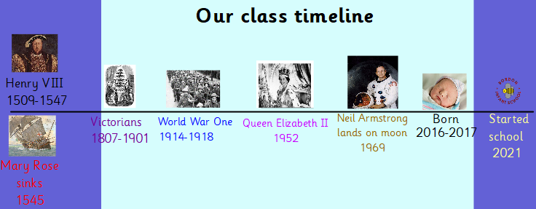
Modern

Tradition

Victorian
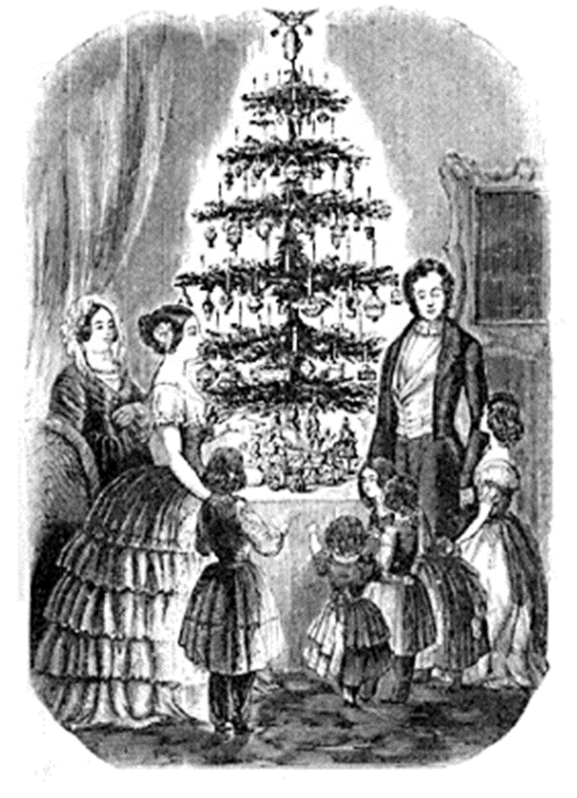

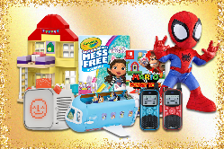
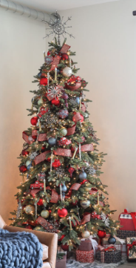
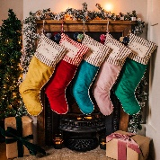
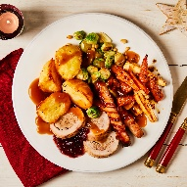
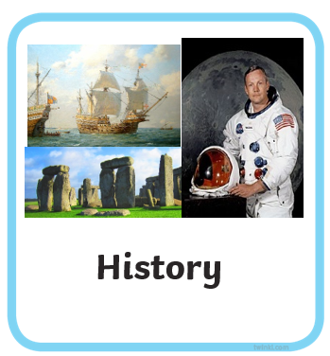

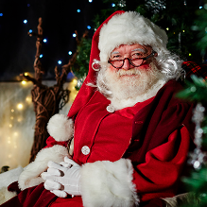
Doing something that has been done for a long time. Often year after year.

The order that things happened in the past.

A period of time nearly 200 years ago.

Things that are in the present and recent times.

What we already know:
We know how we have changed since we were a baby.

Our class timeline
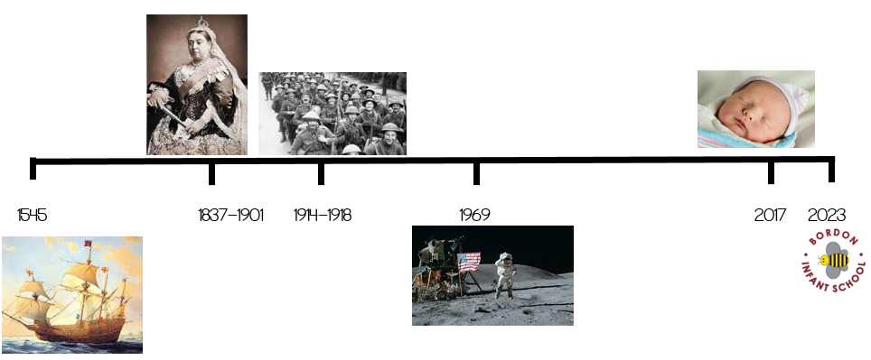
2018
2019
Key Questions:
What does chronological mean?
How can we tell that it is from long ago?
How would it be different if it was happening in modern times?
What has stayed the same and what is different?

