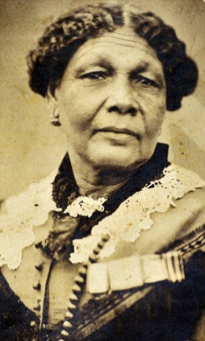

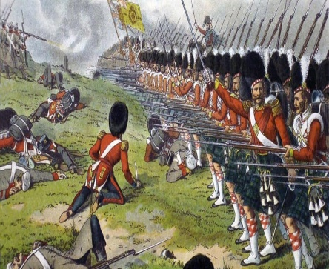
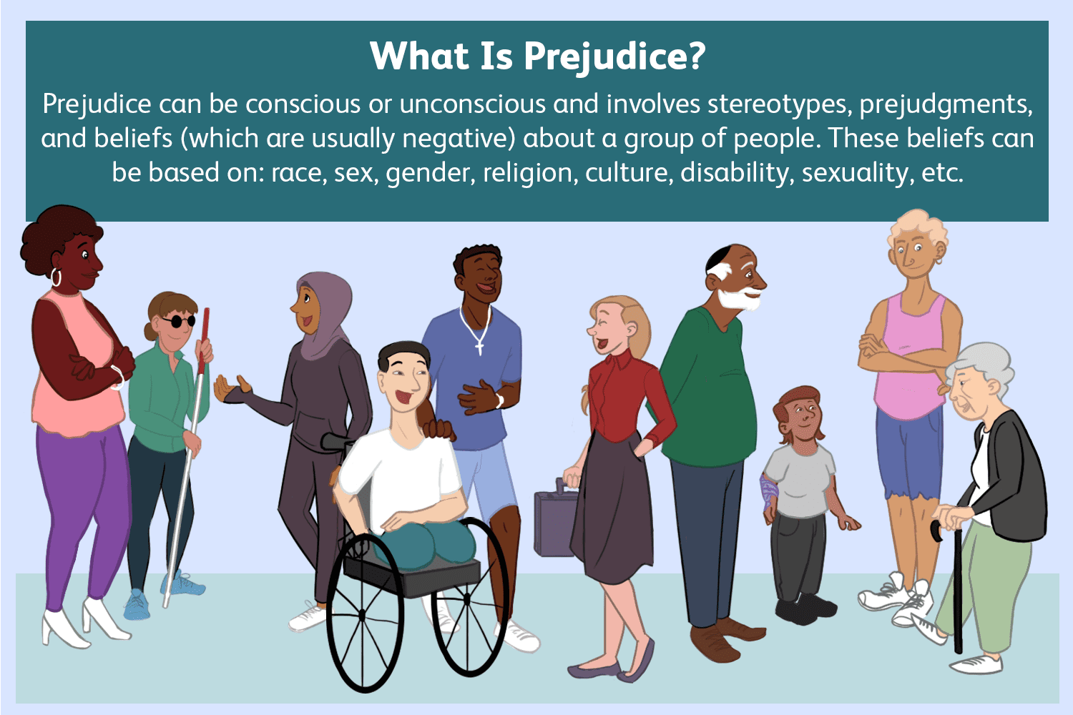

Mary Seacole

Prejudice
Opinions that are not based on reasons or experiences.
Vocabulary

Crimean War Happened in 1853 and lasted 3 years. Countries involved were Russia, France and the United Kingdom.

Doctress
A person that heals others when they are sick using herbs.

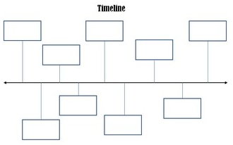
Chronology
The order that things happened in the past.

Previous Learning
Children have identified how we have changed from babies in Year R.
Children have learnt how Victorians celebrated Christmas and how traditions have changed or stayed the same over time.

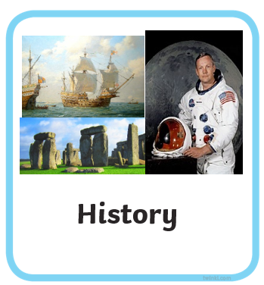
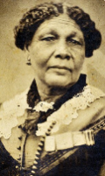
Key Questions:
Who was Mary Seacole?
What did Mary Seacole do?
Why was Mary Seacole important in the past and today?

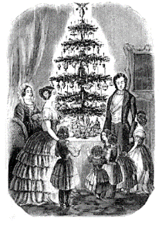
Year 1 Summer 1
Mary Rose

1805-1881


