Knowledge Organiser Music 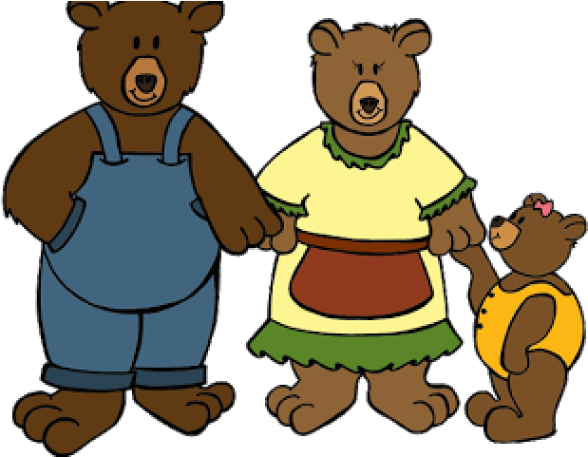The Three Bears
Year 1 - Autumn 1
Musical Element - Pitch: We are learning to explore, respond to and recognise high, middle and low sounds
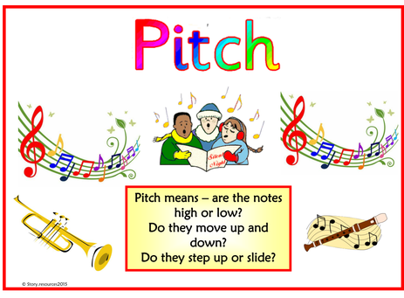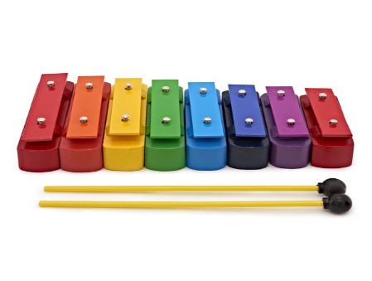
Key Vocabulary
Pitch
High
Middle
Low

Chime bars (low C, middle G and high C)
Skills
Playing
Explore body sounds and learn to use chime bar
Rehearsing and performing
Sing and play in time
Notating
Respond to and recognise signs and symbols
Listening and responding
Respond to and identify sounds from different sources and musical moods, features and how music makes you feel
Describing and discussing
Think and talk about sounds and music and how they make you feel. Use key word - Pitch

