Knowledge Organiser Music - Old Castle – Year 1 – Spring 2 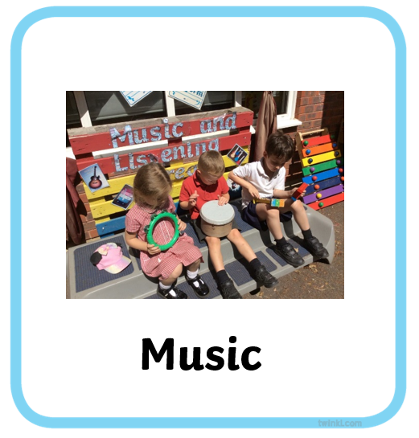
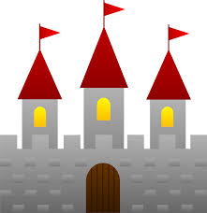
Musical Element - Timbre: Use and identify families of percussion instruments, their sound properties and explore how they could be played. Use and identify vocal sounds and explore how they could be used
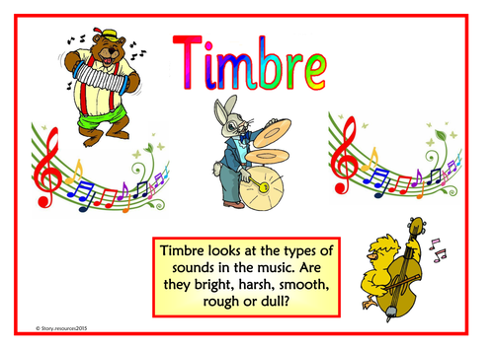
Key Vocabulary
Timbre
Fast(er)
Quiet(er)
Silence

Skills
Playing Explore and use a range of sounds (including body sounds) beginning to use correct percussion techniques
Rehearsing and performing Sing and play in time and follow a range of simple directions including ideas about how to improve and perform
Notating Recognise signs and symbols
Listening and responding Identify sounds from different sources
Describing and discussing Think and talk about sounds and music and how they make you feel.

