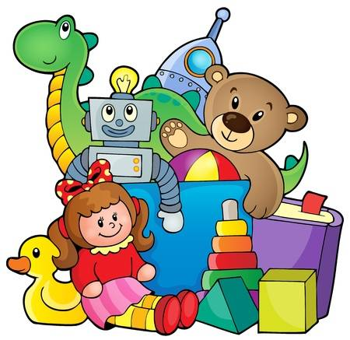Knowledge Organiser Music - Toys – Year 1 – Autumn 2 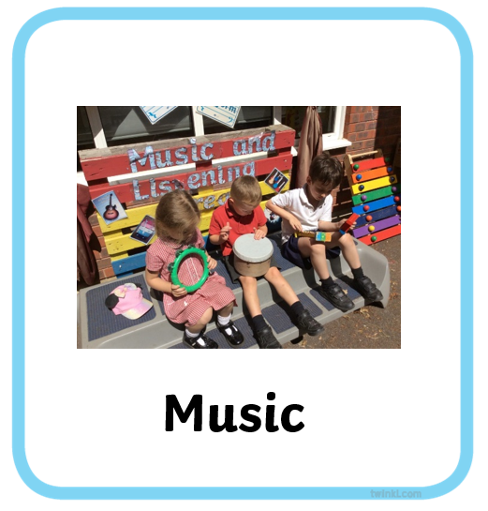

Musical Elements - :Dynamics: Explore, use, respond to, recognise and identify loud, moderate, quiet and silence
Tempo: Explore, use, respond to, recognise and identify fast, moderate and slow
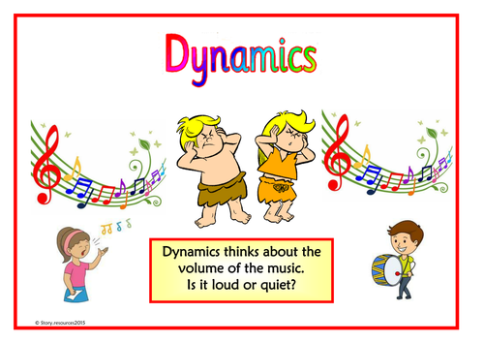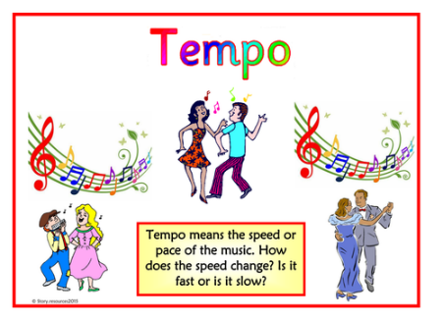
Key Vocabulary
Dynamics
Tempo
Loud/quiet
Fast/slow

Skills
Singing Chant and sing rhymes and songs
Rehearsing and performing Sing and play in time and follow a range of simple directions including ideas about how to improve and perform
Notating Recognise signs and symbols
Listening and responding Explore, recognise and identify sounds from different sources and musical moods
Describing and discussing Think and talk about sounds and music and how they make you feel.

