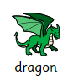
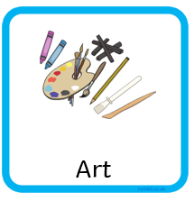
Year 2
Dragonology

Primary colours

Secondary colours




