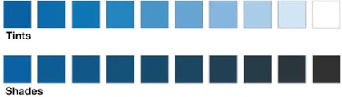
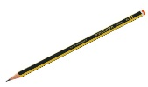
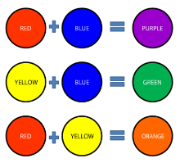
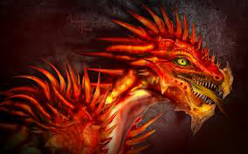
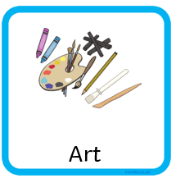
Skills:
-Use pencils to practise shading.
-Mix primary colour paints to make secondary colours.
-Tint and shade colours by adding black or white paint.

We already know:
- How to use a pencil to make an outline of a drawing.
- How to correctly and carefully use a paintbrush.
- How to look carefully at what we are drawing.

Vocabulary:
primary colours: red, blue and yellow. Primary colours cannot be made by other colours. They are used to make secondary colours.
secondary colours: green, purple, orange. Secondary colours are made by mixing two primary colours together.
shading: making a colour darker by adding black.
tinting: making a colour lighter by adding white.

Year 2
Dragonology

