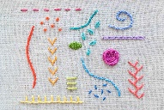
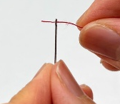
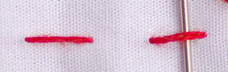
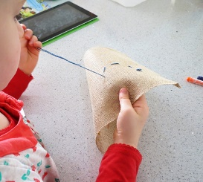
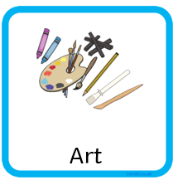
Skills:

We already know:
- How to use a pencil to make an outline of a drawing.
- How to mix primary colours to make secondary colours.
- How to look carefully at what we are drawing.

Vocabulary:
embroidery: the art of decorating fabric by using a needle and thread to create patterns or pictures
thread: when you put thread through the hole in the needle
stitch: a complete movement of needle and thread through the fabric making a small line.

Year 2
Embroidery

