Key Vocabulary
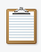  paste | 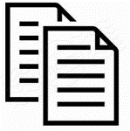  copy | cut   | fill |   size
  select | save   | open   | shade  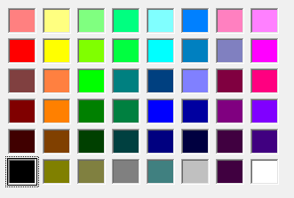 | pixel  
What do I already know?
I can use word to make a document.

I can use different ways to change the way the text looks e.g colour, highlight, italic , bold underline etc

I can use these keys-shift and space bar


I can begin to open and save my document

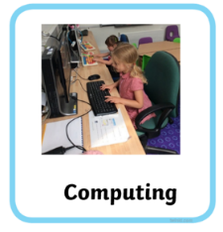
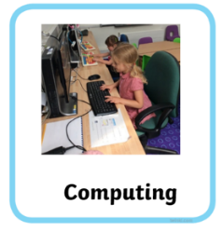
Year 2 Autumn-Using Microsoft Paint
By the end of this unit I will be able to
Use Microsoft Paint to create, save and edit in the style of three famous artists
George Seurat Piet Mondrian Pablo Picasso


