Key Vocabulary
Presentation  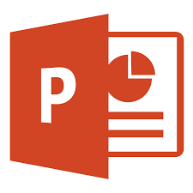  Using text, images or video to communicate |  | Media    Text, video, image,
Text box   | Cursor        Shows the position of the mouse on the screen |  | Insert  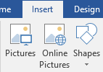
What do I already know?
I can use word to make a document and Microsoft paint to create an image

I can use two hands to type

I can write text on a keyboard,

I can use these keys-shift and space bar

I can undo, redo, bold, italic, underline
and drag

I can import a picture from a saved document
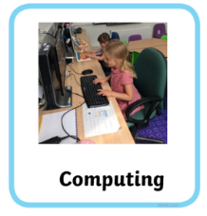
Year 2 Autumn-Using Powerpoint
By the end of this unit I will be able to :-Create a fact file using word about Remembrance with different media to give people information about World war 1


