Key Vocabulary
Microsoft word-Fact file  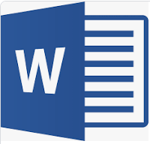  Using text, images or video to communicate. |  | Media    Text, video, image.
Text box  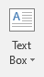 |   Cursor      Shows the position of the mouse on the screen |  | Insert  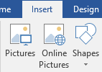
What do I already know?
I can use word to make a document and Microsoft paint to create an image.

I can edit how text looks e.g colour, highlight, italic, bold underline etc.

I can undo, redo, underline and drag.

I can import a picture from a saved document.

I can open and save a document.
By the end of this unit I will be able to : Create a fact file using Microsoft word about Remembrance with different media to give people information about World War I.
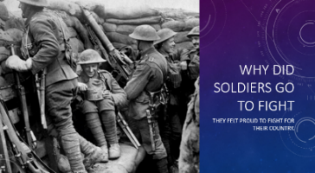
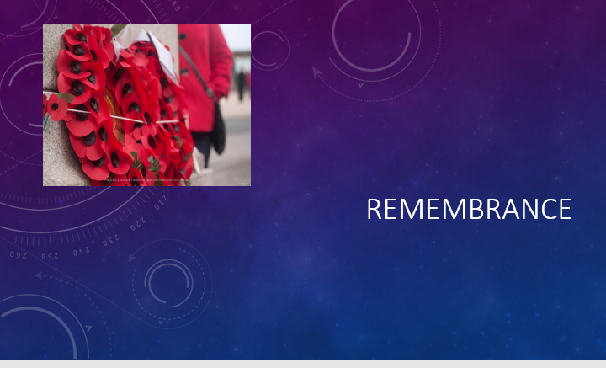
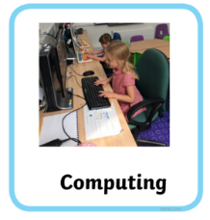
Year 2 Autumn-Usig Microsoft word

