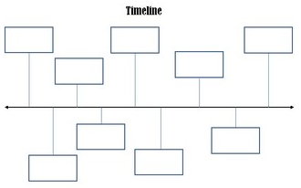
Chronology
The order that things happened in the past.

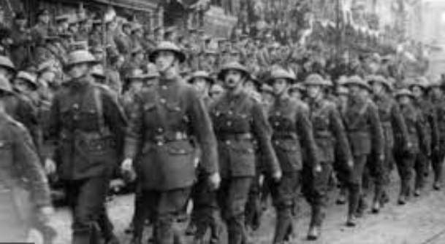
Military
A group of soldiers that will fight for their country.

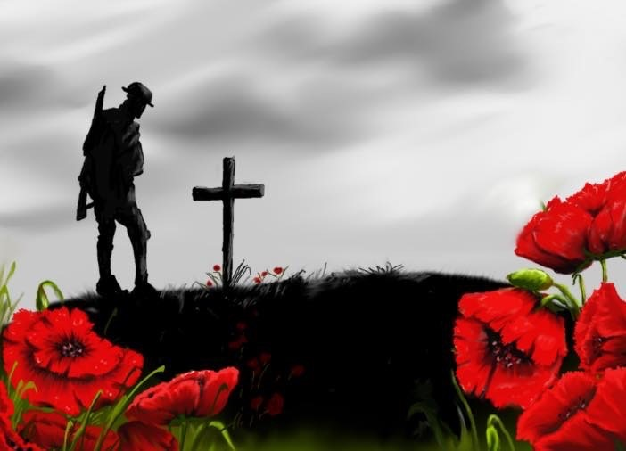
Remembrance
When people wear a poppy and have a minutes silence on 11th November at 11am, to think about the soldiers that died during wars.

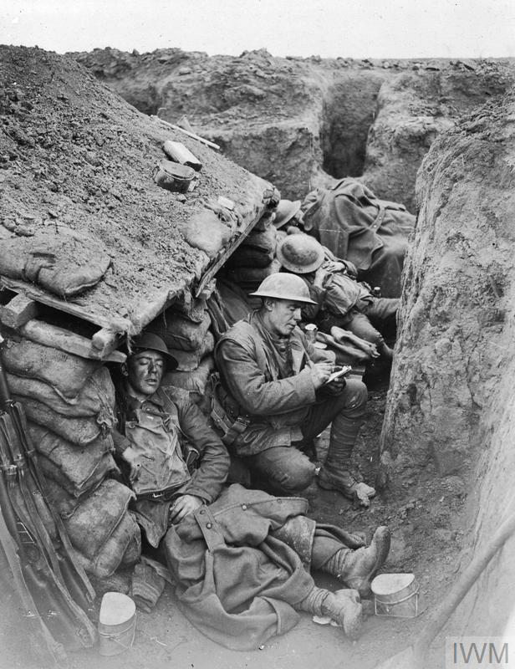
Trenches
A long narrow ditch that was used in the war to keep soldiers safe from the enemy.

5 Key Words
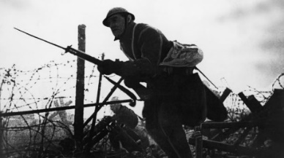

World War I
A war in Europe that happened from 1914–1918.

Previous Learning
Key Questions:
Why do people wear poppies?
How do we find out about the past?
Where and when did the fighting take place?
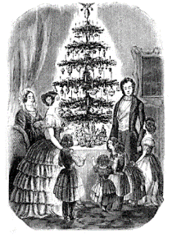
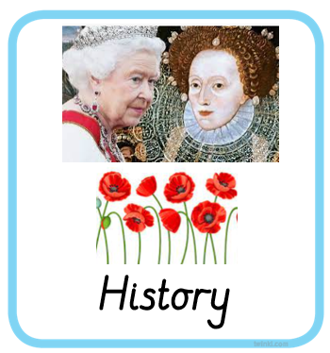
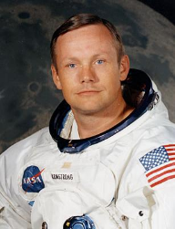
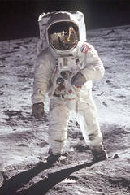

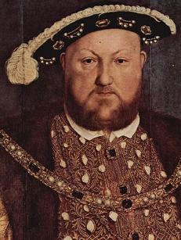
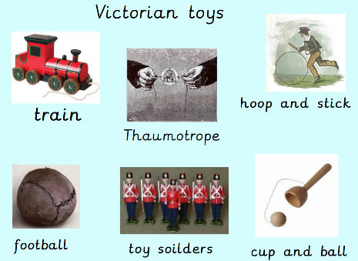
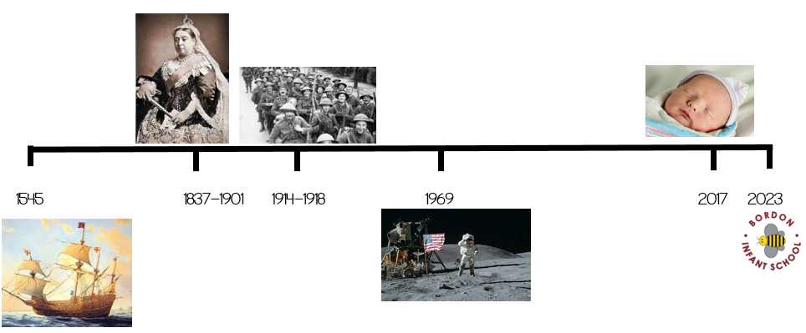
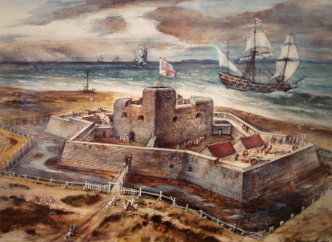
Year 2 Autumn 2
Remembrance

