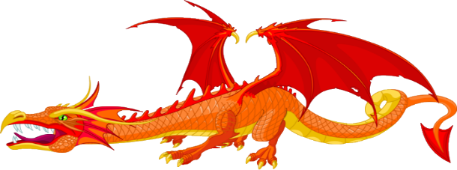Knowledge Organiser Music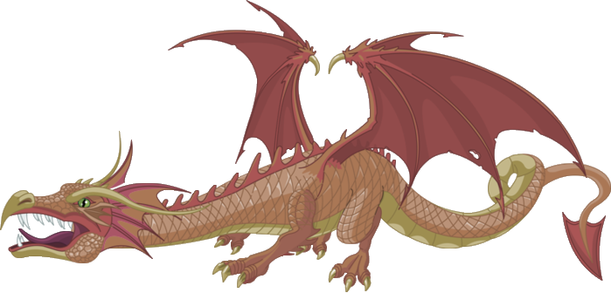
Dragons - Year 2 Autumn 1
Key Vocabulary - Dynamics, loud (forte), quiet (piano), louder, quieter, silence
Tempo, fast, slow, faster, slower
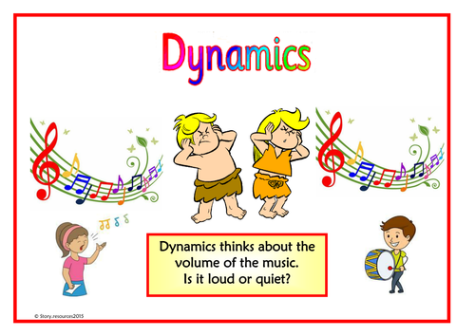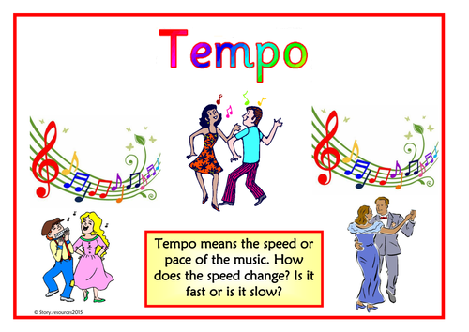
Skills
Singing: sing a wider variety of rhymes and songs with an awareness of character and or mood.
Playing: use correct technique on a range of untuned percussion instruments
Rehearsing and performing: sing and play in time and follow a wider range of simple directions, develop awareness of why and how to improve
Notating: respond to, identify and use symbols and other graphic notation
Listening and responding: Begin to consider how music tells the composer’s ideas
Describing and discussing: think and talk about what you hear, begin to explore the ideas behind the music and how they make you feel. Use key words when talking about the music

