Knowledge Organiser Music – Jolly Roger – Year 2 – Spring 2 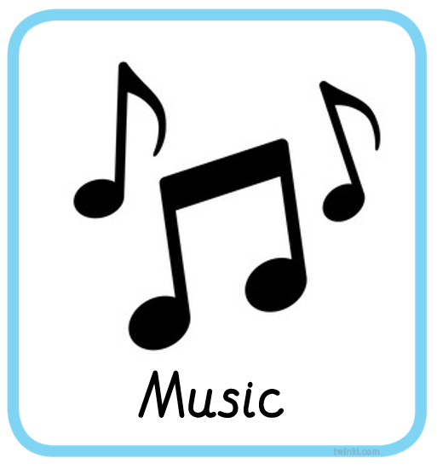

Musical Element - Structure and Timbre: Use and identify families of percussion instruments, their sound properties and explore how they could be played. Use and identify vocal sounds and explore how they could be used
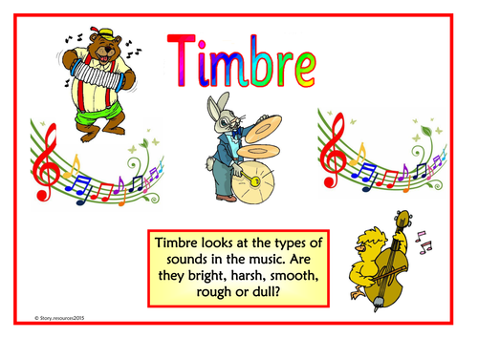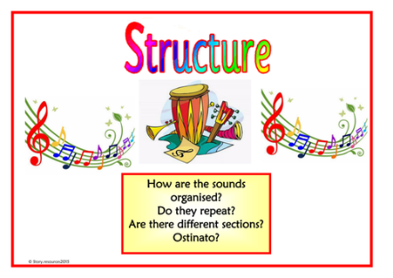
Key Vocabulary
Timbre
Verse and chorus
Structure

Skills
Singing
Chant and sing a wider variety of rhymes and songs with an awareness of character and mood.
Rehearsing and performing
Sing and play in time and follow a wider range of simple directions
Notating
Identify and use symbols
Listening and responding
Begin to consider how music illustrates the composer’s ideas
Describing and discussing
Think and talk about what you hear, begin to explore the ideas behind the music and how they make you feel.

