Knowledge Organiser Music – Minibeasts on the Move – Year 2 – Summer 2 
Musical Element - Duration:
Key Vocabulary
duration
steady beat
rhythm
pattern

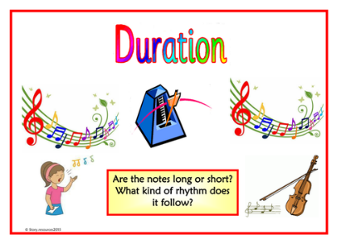
Skills
Playing
Begin to correctly play a range of untuned percussion instruments
Rehearsing and performing
Sing and play in time and follow a range of simple directions, know how to improve and why
Notating
Use symbols
Listening and responding
Are the notes long or short? What kind of rhythm does it follow?
Describing and discussing
Think and talk about what you hear, begin to explore the ideas behind the music and how they make you feel. Use key words relating to the dimensions

