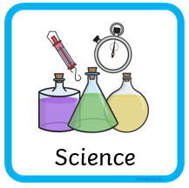
Key Vocab | Description
material | What something is made from – wood, stone, plastic, metal, glass, paper
properties | Opaque, hard, flexible, fragile, transparent, soft, ridged, durable
natural | Something that grows, is made by earth or appears in our environment without the involvement of humans (wood, wool, stone)
man-made | Humans need to create these materials as they do not appear naturally (glass, plastic, metal)
absorbent | Allows water (liquid) to be entered (sucked in and stored)
stretch | A material that can be pulled and its shape changed without causing damage/break
repellent | Stops water (liquid) from entering it (sucked in)
durable | A material that stays the same when squashed, pulled and used (tough)

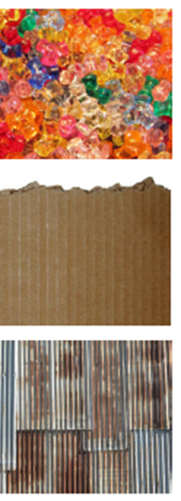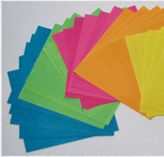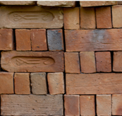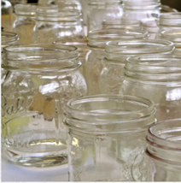

Talking Points:
Q: If you were to build a house, what material would you choose? Why?
Q: If you wanted a new drinking cup, what material would you choose? Why?
Q: Which material would be the most fragile?
Q: Would any of these materials be flexible?
Q: Can you think of any more/different materials not in the pictures above?

