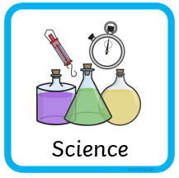
Key Vocab | Description
alive | living things are able to move, breathe, grow, have babies, get rid of waste (in humans, ‘wee’ and ‘poo’) and eat.
dead | Dead things were once alive (see alive description) but now are not.
never been alive | Items that have never been able to move, grow, breathe, have babies or get rid of waste.
carnivores | Carnivores only eats meat. They often catch other animals and include insects.
herbivores | Herbivores only eats plants. These can be flowers, fruit, nuts, grass.
omnivores | Omnivores eat plants and meat. These can be a mixture of all carnivore and herbivore food.
characteristics | Parts of the body or behaviour of an animal.

Talking Points:
Which picture is alive? Which picture is dead? Which picture has never been alive?
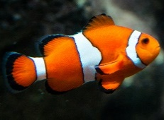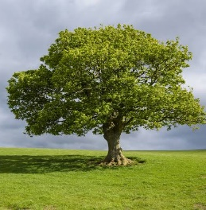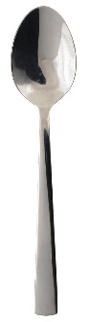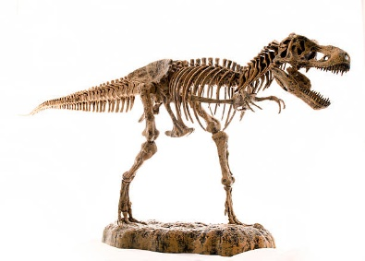

By looking at these animal teeth, which one do you think is a
carnivore herbivore omnivore? Why?


