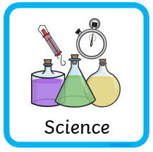
Key Vocab | Description
germination | The first stage of a plant life cycle. From seed to shoot.
photosynthesis | The process that plants go through to turn sunlight into food.
survival | The ability to continue to grow into the next stage of its life cycle. This hopefully is in a healthy, strong way.
nutrition or  nourishment | The ‘food’ the plant needs to grow into a healthy adult plant (mostly found in soil).
dispersal | Plants ‘disperse’ (let go of/spread) their seeds by blowing, eating, exploding, floating, falling, sticking. The design of a seed is crucial to the way it is dispersed.
temperature | How hot or cold the environment (place) around the plant where it is living.
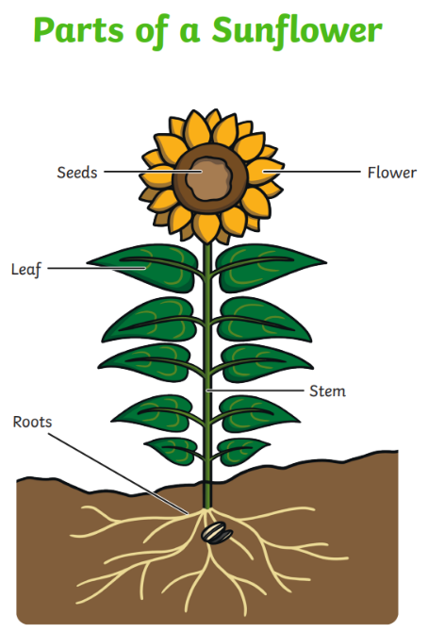
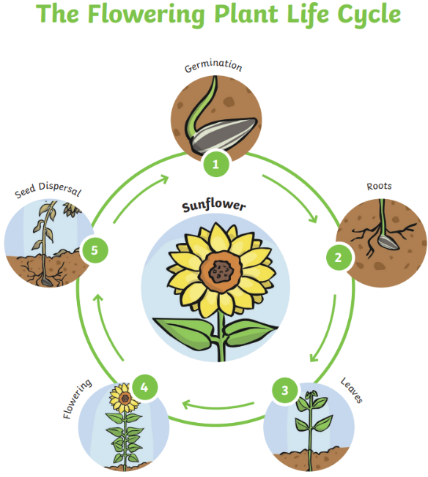

Talking Points: Take a look outside
Can you find any plants in the seedling stage of their lifecycle?
Can you find any plants in the flowering stage of their lifecycle?

