Key Vocab | Description
habitat | The place where a plant or animal lives is known as a habitat e.g desert, mountains, forest.
micro-habitat | A micro-habitat is a smaller more specific area that an animal or plant lives. e.g the damp underside of a stone in the forest could provide shelter for a woodlouse. A rotting log may become home to a number of different mini-beasts or maybe a clump of moss.
life-cycle | The different stages and physical changes animals and plants go through in their life.
food chain | A food chain is a sequence describing how different animals eat each other, showing the order in which living things depend on each other for food.
producer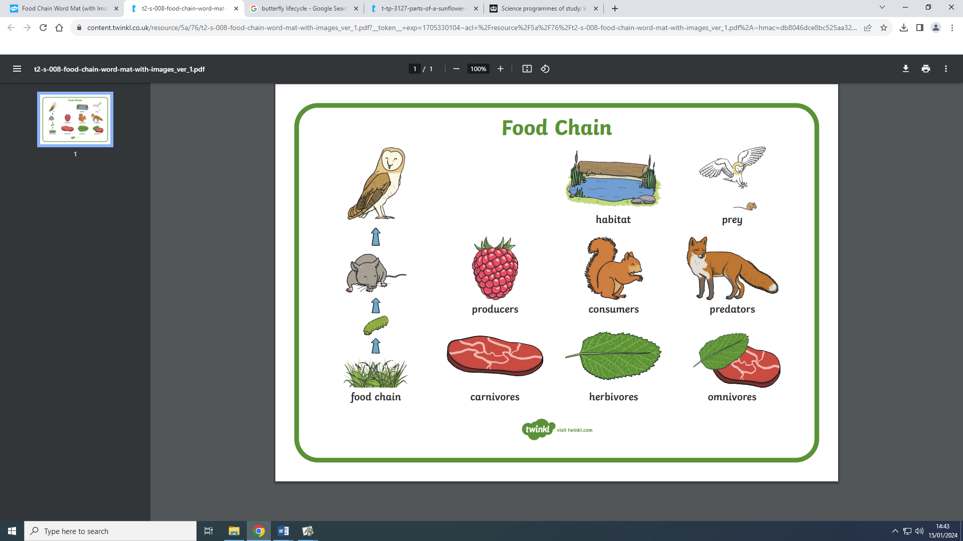 | A producer is often a plant as it creates its own food e.g grass, flowers, fruit, leaves. This is the FIRST stage of a Food Chain.
consumer | A consumer is often an animal that eat the producers (plants) and are mostly herbivores or omnivores e.g squirrels, caterpillars, grasshopper, rabbits.
prey 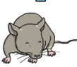 | Prey can be a mixture of a consumer that eats the plants and/or a smaller carnivore that eats other animals in the food chain e.g rats, mice, frogs, rabbits. Depending on the food chain, any of these might be the last one on the top.
predator | Most of the time, the animal at the top of the food chain is a predator who eats meat, either as a carnivore or an omnivore. The predator at the very top of the food chain, that nothing else eats, is called an apex predator e.g fox, human, owl.
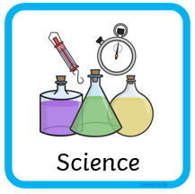
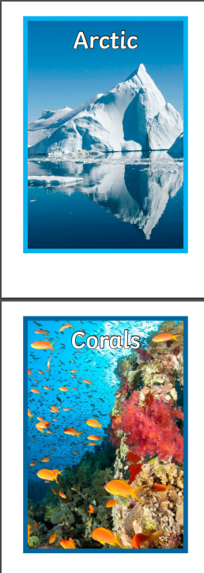
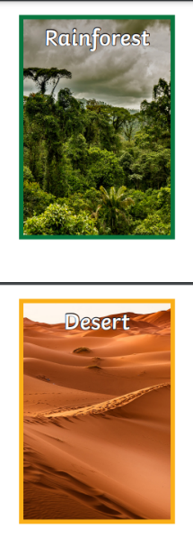
Food Chain Habitats Life Cycles
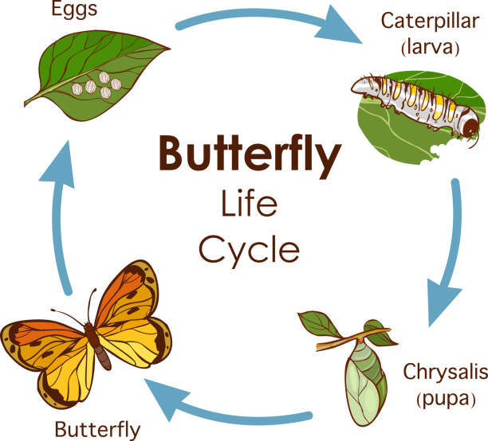
predator

prey
consumer
producer



