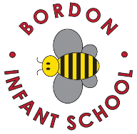
Bordon Infant School Remote Education Provision: Information for Parents

This information is intended to provide clarity and transparency to parents or carers about what to expect from remote education where national or local restrictions require entire cohorts (or bubbles) to remain at home.

For details of what to expect where individual pupils are self-isolating, please see the final section of this page

The Remote Curriculum: what is taught to children at home
A pupil’s first day or two of being educated remotely might look different from our standard approach, while we take all necessary actions to prepare for a longer period of remote teaching.

What should my child expect from immediate remote education in the first day or two of children being sent home
If children are sent home, then their class teachers will email as soon as possible that day some work for them to do for the following day. Where possible we will include work for the day they are sent home.
The work will be linked to the learning that is/would have been taking place in class.
Parents will be able to email the class teacher any questions or support they might have.

Following the first few days of remote education, will my child be taught broadly the same curriculum as they would in school?
We teach the same curriculum remotely as we do in school.

Remote teaching each day
The government has set a target of 3 hours of work a day for Infant school children on average. Year R may get a bit less than this and Year 2 may get a bit more.

All remote learning will follow the normal school curriculum. Adaptations will be made to the remote activities to ensure they are suitable for remote learning

The remote teaching children will receive will fall into two categories:
Children self isolating while the majority of the class remain in school
You will be sent by email work for English, Maths and topic work either daily or every couple of days. Teachers will be available by email to support you but will only be able to answer at the end of the school day. Where possible teachers will make themselves available for a short conversation by phone or by Teams web chat once a week.

Whole school or bubble closures
You will be emailed a timetable with links to online teaching via Teams. There will be two online sessions a day depending on the child there will either be a phonics lesson or a writing lesson. There will also be an online live Maths lesson. Alongside the two online lessons you will also be sent independent English and topic work for you to do with your child daily.

Year R
- Most of the independent learning sent home in Year R will be practically based. More so at the start of the year
- Tapestry will be used as an additional method of communication alongside Teams and email
- We will limit the amount of printing out of work you will need to do. Where we feel this is essential we will make packs of work available from the school office
- There will be online teaching twice a day, one for phonics and one for Maths

Year 1
- The focus for Year 1 will be on phonics. Phonics will be taught online in small groups
- There will also be an online Maths lesson taught as a whole class
- We will limit the amount of printing out of work you will need to do. Where we feel this is essential we will make packs of work available from the school office
- There will be topic activities set as independent learning for the afternoon

Year 2
- Online teaching will consist of a daily whole class writing lesson. Some children may join in the Year 1 phonics lessons instead where this is deemed more appropriate for them
- There will be a daily whole class Maths lesson followed by independent activities
- There will be topic activities set as independent learning for the afternoon

Accessing remote education
Most of our communication will be via email. Please make sure the school has your correct email address.
All online teaching will take place through Microsoft Teams. This can be downloaded most easily by Googling Microsoft teams.
Year R and some Year 1 content will also be put on Tapestry.

If my child does not have digital or online access at home, how will we as a school support you
Please contact the school if you have any issues. We have a small number of laptops that we can loan to support you while you need to learn remotely. All the laptops need is to be connected to your home wifi.
We will provide printed packs of work that can be collected from the school office on request.
If for any other reason you are struggling, please speak to us and we will do all we can to help.

Engagement in remote learning
- Our expectation is that children attend all live lessons, unless ill or there is a family emergency
- We expect children to complete all work that is sent home to them
- For some subjects where the children are learning without any live lessons we may ask for a copy of some of the children’s work to be sent to the class teacher
- Teachers will take a register every session. They will follow up with an email or a phone call if a child misses two sessions in a row or there are repeated absences

Feedback and Assessment
Feedback can take many forms and may not always mean extensive written comments for individual children. For example, whole-class feedback or quizzes are also valid and effective methods, amongst many others. Our approach to feeding back on pupil work is as follows:
- Teachers will give direct feedback in online lessons
- Assessment will take place during online lessons through teachers asking direct questions or gauging children’s understanding through a variety of visual methods, such as thumbs up
- Teachers will request examples once a week of writing for those children in Year 2 who are given writing activities which are not linked to online teaching

Additional support for children with particular needs
We recognise that some pupils, for example, pupils with special educational needs and disabilities (SEND), may not be able to access remote education without support from adults at home. We acknowledge the difficulties this may place on families, and we will work with parents and carers to support those pupils in the following ways:
- Individual support will be given by the class teacher and/or the LSA to help you with understanding the best way to access the remote education
- Additional support will be available from the school SENCo

The key to the best possible remote education is good communication between home and school. We will do everything we can to balance the pressures parents are under while aiming for the highest possible education for your child. We ask parents to balance the need for school support with the understanding that teachers are supporting a large number of children possibly both in school and at home.
We are a fantastic school community and we all want the very best for each and every child.

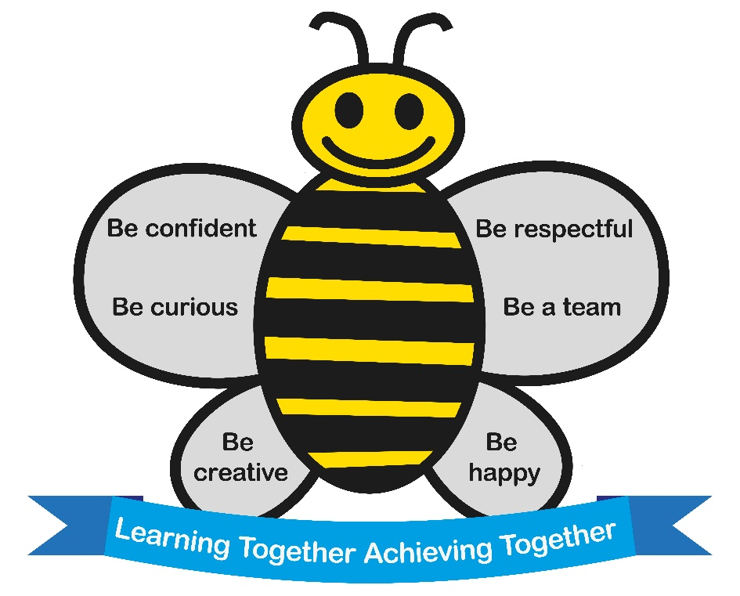

Agreed by the Governors January 2021

